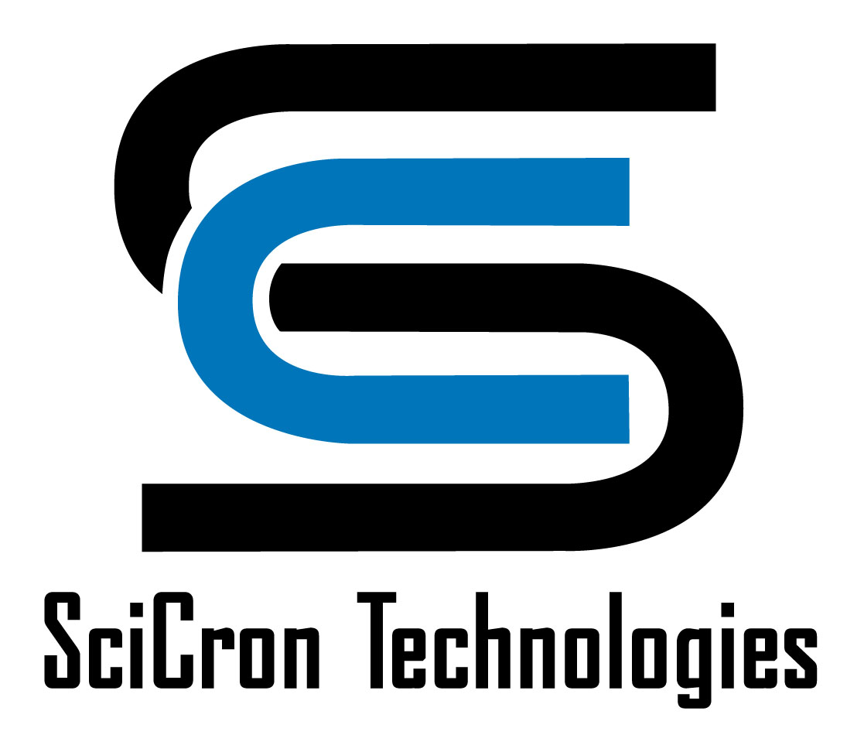
Product
Information

AC-300™ Acrylic
Static Dissipative Plastic

Description
AC-300™ Acrylic is a plastic sheet product designed to control static electricity for a wide range of end uses. It is a premium quality acrylic sheet which has been surfaced with SciCron Technologies proprietary, clear, C-300™ static dissipative surfacing. This unique technology prevents charge generation on the sheet surfaces, thereby controlling particulate attraction and preventing electrostatic discharge (ESD) events. This performance is permanent and totally independent of humidity. AC-300 Acrylic offers exceptional design versatility since it fabricates simply, is light in weight and is available in large sheet sizes. It also exhibits excellent optical properties, chemical resistance, surface hardness and mar resistance.

Applications
AC-300 Acrylic resists tribocharging under all circumstances and cannot generate a charge when properly grounded. This makes it ideal for use in manufacturing and assembly operations for charge sensitive electronic components where it can help prevent both immediate and latent ESD caused defects. Since it resists charge build-up it does not attract contaminants, so it can also help prevent contamination-related rejects in ultra-clean manufacturing operations. Consequently, it is suitable for use in the semi-conductor, electronic, and micro-manufacturing industries. Typical applications include; covers, windows, doors, and access panels for electronic equipment, machines and instruments; fabricated desiccators, cabinets, and boxes; transparent room partitions and pass-thru modules; process equipment enclosures; and mini-environment glazing panels. The product also has many general industrial uses, including protection for static charge sensitive manufacturing devices and control of spark discharge in explosive environments.

Fabrication
AC-300 Acrylic is easily fabricated into flat surface configurations using the same equipment and fabrication techniques generally employed with unsurfaced acrylic sheet products. It should not be used for heat formed bent configurations since the hard, cured C-300 surface is not designed for heat bending. When solvent welding, it is necessary to remove the C-300 surface mechanically to achieve a good bond. For more information on fabrication refer to SciCron Technologies Technical Information Bulletin No. SP-01.

The information and statements contained herein are believed to be accurate, however, users should perform their own testing and verification to determine the durability, applicability and suitability of the products for their own purposes. NOTHING CONTAINED HEREIN SHALL BE CONSTRUED AS A REPRESENTATION OR WARRANTY OF ANY KIND, EXPRESS OR IMPLIED, or as permission, inducement, or recommendation to practice any patented invention without license. IMPLIED WARRANTIES OF MERCHANTABILITY OR FITNESS FOR A PARTICULAR PURPOSE ARE HEREBY EXCLUDED. While SciCron Technologies’ surface is more mar resistant than the original substrate, the term “Permanent” or “Permanence” is not intended as a guarantee of durability in any particular application. It is used to distinguish SciCron Technologies’ surface from topical anti-stats which must be reapplied on a regular basis.

SciCron Technologies, LLC • 501 Amarillo Blvd, West • Amarillo, TX 79107-5179 • 806-372-8300 • 800-660-0809 • FAX/806-372-8333 • info@sctech.com

Features and Benefits
● Cannot be tribocharged when properly grounded
Prevents build-up of static charge and accumulation of harmful contamination.
● Electrostatic decay in less than 0.05 second per Federal Test Standard 101C, Method 4046.1
Results in rapid static dissipation without arcing.
● Surface resistivity of 10⁶ - 10⁸ ohms per square
Provides for ESD control without the need for ionization.
● Permanence in static dissipation performance
Avoids cost of application of temporary topical anti-stats.
● Humidity independent static charge control
Avoids inconvenience of maintaining high levels of humidity and damage caused by such humidity.
● Advanced technology, uniform surface treatment
Avoids conductive discontinuities (charged “hot spots”) often found with non-uniform temporary topical anti-stats.
● Excellent optical properties
C-300 surface provides excellent clarity for optimum use of available light.
● Superior chemical resistance
Reduces risk of solvent or chemical surface damage.
● Hard, mar resistant, durable surface
C-300 surface, harder than the base plastic, reduces risk of damage to the sheet surfaces.
● Superior fabrication characteristics
Results in optimum workability during part fabrication.

Availability
AC-300 Acrylic, in cell cast type, is available in clear and a variety of standard transparent colors including tints which filter wave-lengths that can interfere with processing opera-tions. White translucent and colored opaque grades are also available. Continuously cast and extruded types are available in some sizes and thicknesses upon request.

Note: Cell cast is a premium form of acrylic plastic but it has a wider thickness variation than other acrylic types. Therefore, continuously cast or extruded material should be specified if a narrow thickness tolerance range is required.

Standard Dimensions (Nominal)
Thickness: 3mm (1/8”), 4.5mm (3/16”), 6mm (1/4”), 9mm (3/8”), 12mm (1/2”) - Note: 9mm and 12mm - cell cast only.
Standard Sheet Size: 48” x 96”
Other sizes and thicknesses, including oversize sheets, available upon request.
Made in USA

AC-300™ Acrylic
Typical Physical Properties (Typical but not guaranteed values for 0.25 inch cell cast material)
Property | Test Method | Units | AC-300 Acrylic
Physical  Specific Gravity  Pencil Hardness | ASTM D792  ASTM D3363 | --  Hardness Scale | 1.19  5H
Mechanical  Tensile Strength  Ultimate  Elongation  Tensile Modulus  Flexural Strength  Flexural Modulus  Compressive Strength  Izod Impact Strength (milled notch) | ASTM D638  ASTM D638  ASTM D638  ASTM D790  ASTM D790  ASTM D695  ASTM D256 | psi  %  psi  psi  psi  psi  ft-lb/inch of notch | 10,000  4.2  400,000  16,500  475,000  18,000  0.4
Thermal  Deflection Temperature (264 psi load)  Vicat Softening Point  Maximum Continuous Service Temperature  Coefficient of Thermal Expansion  Coefficient of Thermal Conductivity | ASTM D648  ASTM D1525  --  ASTM D696  Cenco-Fitch | °F  °F  °F  in/in/°F  BTU•in/hr•ft²•°F | 210  239  180  3.5 x 10-5  1.3
Flammability  Horizontal Burn (Flame Spread)  UL 94 Rating of the Uncoated Substrate | ASTM D635  UL 94 | in/min  UL Classification | 1.1  HB
Optical  3mm Transparent Clear Transmittance - Total  Haze | ASTM D1003  ASTM D1003 | %  % | 80  Less than 3.0
Electrical  Surface Resistivity  Surface Resistance  Electrostatic Decay | ASTM D257  EOS/ESD S11.11  FTS 101C,  Method 4046.1* | ohms/sq  ohms  sec | 106 - 108  105 - 107  Less than 0.05

* Federal Test Standard 101C, Method 4046.1 as described in EIA-541, Appendix F, Measurement of Electrostatic Decay Properties of Dissipative Planar Materials

Chemical Resistance ASTM D543
Samples immersed in the specified chemicals for 24 hours at room temperature and visually examined.

Chemical | Surface Attack | Visual Evaluation
Deionized Water | None | Clear
30% Sodium Hydroxide | None | Clear
30% Sulfuric Acid | None | Clear
30% Nitric Acid | Slight Pitting | Clear
48% Hydrofluoric Acid | Severe Attack | White,  Rubbery
Methanol | Slight Pitting | Clear
Ethanol | None | Clear
Isopropyl Alcohol | None | Clear
Acetone | Severe Pitting | Coating  Clear-  Plastic Attacked
Methylene Chloride | Sample  Dissolved | Sample Dissolved

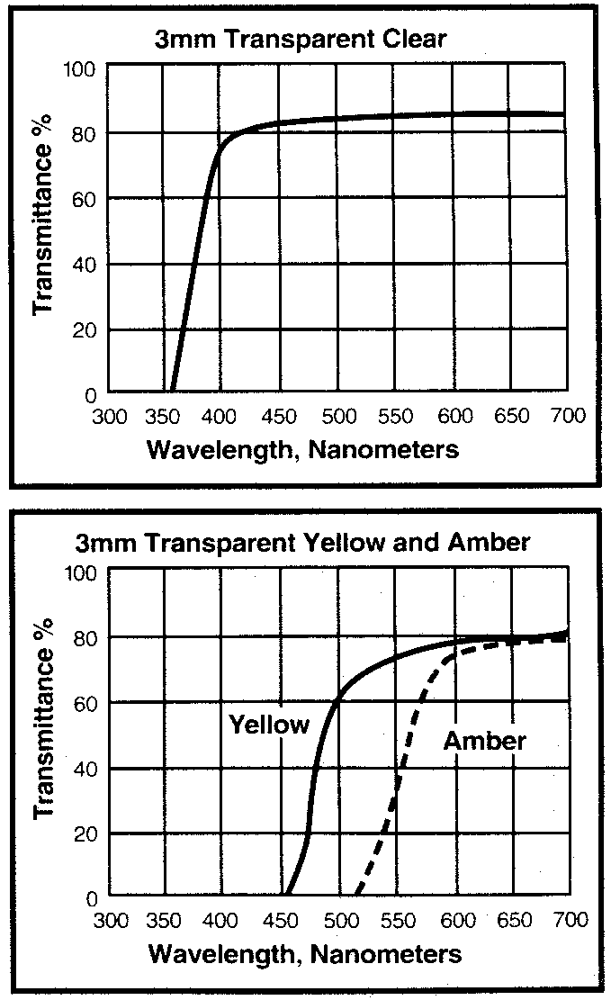Light Transmission Spectral Analysis

Precautions:
1. Acrylic plastic is a combustible thermoplastic. Avoid exposure to flame and excessive heat. Observe fire precautions appropriate for comparable forms of wood and paper.
2. For building applications, comply with applicable code regulations.
3. Clean with soap and water. Do not use abrasives. Avoid inappropriate contact with solvents. AC-300-8 2/04

